МИНИСТЕРСТВО НАУКИ И ВЫСШЕГО ОБРАЗОВАНИЯ РОССИЙСКОЙ ФЕДЕРАЦИИ
федеральное государственное автономное образовательное учреждение высшего образования
«САНКТ-ПЕТЕРБУРГСКИЙ ГОСУДАРСТВЕННЫЙ УНИВЕРСИТЕТ
АЭРОКОСМИЧЕСКОГО ПРИБОРОСТРОЕНИЯ»
ИНСТИТУТ НЕПРЕРЫВНОГО И ДИСТАНЦИОННОГО ОБРАЗОВАНИЯ
КАФЕДРА компьютерных технологий и программной инженерии

ОЦЕНКА
ПРЕПОДАВАТЕЛЬ
должность, уч. степень, звание |  | подпись, дата |  | инициалы, фамилия

ОТЧЕТ О ЛАБОРАТОРНОЙ РАБОТЕ

«РАБОТА С ИСТОЧНИКОМ СВЕТА И СВОЙСТВАМИ ИСТОЧНИКОВ И МАТЕРИАЛОВ»

по дисциплине: Компьютерная графика
РАБОТУ ВЫПОЛНИЛ
СТУДЕНТ ГР. № | Z9431 |  |  |  |  | Андреев Д.И.
 | номер группы |  |  | подпись, дата |  | инициалы, фамилия
Студенческий билет № | 2019/3781

Санкт-Петербург 2020

Оглавление
1. Задание 3
2. Листинг программы 3
3. Выводы 21

- Задание

Включить 3 источника света, задать отражающие свойства поверхностей, положение и цвет источников света. Цвет поверхностей сделать одинаковым, а отражающие свойства – разными. Вывести несколько объемных объектов. Источники света должны иметь различный цвет. Необходимо организовать вращение сцены, управляемое с клавиатуры (сцена с объектами объекты вращается, источники неподвижны).

- Листинг программы

Файл main.cpp
#include <QGuiApplication>
#include <QSurfaceFormat>
#include "mainwindow.h"

int main(int argc, char *argv[])
{
QGuiApplication::setAttribute(Qt::AA_EnableHighDpiScaling);
QGuiApplication app(argc, argv);

MainWindow win;
win.open();

return app.exec();
}

Файл mainwindow.h – содержит класс главного окна программы

#ifndef MAINWINDOW_H
#define MAINWINDOW_H

#include <QObject>

class QuickItem;
class QQuickView;
class QQmlEngine;

class MainWindow : public QObject
{
Q_OBJECT
public:
explicit MainWindow(QObject *parent = nullptr);

public slots:
void open();

private:
QQuickView *m_view;
QuickItem *m_item;
QQmlEngine *m_engine;
};

#endif // MAINWINDOW_H
Файл mainwindow.cpp – содержит реализацию методов класса MainWindow

#include "mainwindow.h"
#include "quickitem.h"
#include "gllight.h"
#include <QQuickView>
#include <QQmlEngine>
#include <QGuiApplication>

MainWindow::MainWindow(QObject *parent) :
QObject(parent)
, m_engine(new QQmlEngine)
{
qmlRegisterType<QuickItem>("opengl_lib", 1, 0, "QuickItem");
qmlRegisterType<GLLight>("opengl_lib", 1, 0, "GLLight");

m_view = new QQuickView(m_engine, nullptr);
m_view->setResizeMode(QQuickView::SizeRootObjectToView);
m_view->setSource(QUrl("qrc:/main.qml"));

m_item = m_view->rootObject()->findChild<QuickItem *>();
}

void MainWindow::open()
{
m_view->show();
m_item->update();
}

Файл quickitem.h – содержит класс 3D объекта

#ifndef QUICKITEM_H
#define QUICKITEM_H

#include <QQuickItem>
#include <QtGui/QOpenGLFunctions_3_3_Core>
#include <QQuickWindow>

class GLCamera;
class GLLight;
class QSGSimpleTextureNode;
class QOpenGLTexture;
class QOpenGLShaderProgram;

class QuickItem : public QQuickItem
{
Q_OBJECT
Q_PROPERTY(float specStrength READ specStrength WRITE setSpecStrength NOTIFY specStrengthChanged)
Q_PROPERTY(float specIntensity READ specIntensity WRITE setSpecIntensity NOTIFY specIntensityChanged)
Q_PROPERTY(GLLight* light_1 READ light_1 NOTIFY light_1Changed)
Q_PROPERTY(GLLight* light_2 READ light_2 NOTIFY light_2Changed)
Q_PROPERTY(GLLight* light_3 READ light_3 NOTIFY light_3Changed)
Q_PROPERTY(QColor objectColor READ objectColor WRITE setObjectColor NOTIFY objectColorChanged)

struct LightUniforms {
GLint modelLoc;
GLint viewLoc;
GLint projLoc;
GLint colorLoc;
};

struct MainUniforms {
GLint modelLoc;
GLint viewLoc;
GLint projLoc;
GLint objectColorLoc;
GLint lightPosLoc_1;
GLint lightPosLoc_2;
GLint lightPosLoc_3;
GLint viewPosLoc;
GLint scepStrengthLoc;
GLint scepIntensityLoc;
GLint lightColorLoc_1;
GLint lightColorLoc_2;
GLint lightColorLoc_3;
GLint lightCount;
};

public:
QuickItem(QQuickItem *parent = nullptr);
~QuickItem();

float specStrength() const;
float specIntensity() const;

GLLight *light_1() const;
GLLight *light_2() const;
GLLight *light_3() const;

QColor objectColor() const;

protected:
virtual void keyPressEvent(QKeyEvent *event) Q_DECL_OVERRIDE;
virtual QSGNode *updatePaintNode(QSGNode *pNode, UpdatePaintNodeData *pData) Q_DECL_OVERRIDE;

public slots:
void setSpecStrength(float specStrength);
void setSpecIntensity(float specIntensity);

void setObjectColor(QColor objectColor);

signals:
void specStrengthChanged(float specStrength);
void specIntensityChanged(float specIntensity);
void light_1Changed(GLLight* light_1);
void light_2Changed(GLLight* light_2);
void light_3Changed(GLLight* light_3);
void objectColorChanged(QColor objectColor);

private:
void initFBO(int width, int height, QSGSimpleTextureNode *node);
void doRender(QSGSimpleTextureNode *pTextureNode);
void pushOpenGLMatrix();
void initShader();
void initOpenGLState();

QOpenGLFramebufferObject *m_pSourceFbo;
QOpenGLFramebufferObject *m_pTargetFbo;
QOpenGLShaderProgram *m_program;
QOpenGLShaderProgram *m_lightProgram;
// QOpenGLTexture *text1;
// QOpenGLTexture *text;
GLCamera *m_camera;
GLLight *m_light_1;
GLLight *m_light_2;
GLLight *m_light_3;
QOpenGLFunctions_3_3_Core m_glFuncts;
bool m_isOpenGLInitialized;
GLuint m_VBO, m_VAO;
GLuint m_firstLightVAO, m_secLightVAO, m_thirdLightVAO;
GLfloat m_specStrength;
GLfloat m_specIntensity;
MainUniforms m_mainUn;
LightUniforms m_lightUn;
QColor m_objectColor;
GLfloat m_verts[216]{
-0.5f, -0.5f, -0.5f, 0.0f, 0.0f, -1.0f,
0.5f, -0.5f, -0.5f, 0.0f, 0.0f, -1.0f,
0.5f, 0.5f, -0.5f, 0.0f, 0.0f, -1.0f,
0.5f, 0.5f, -0.5f, 0.0f, 0.0f, -1.0f,
-0.5f, 0.5f, -0.5f, 0.0f, 0.0f, -1.0f,
-0.5f, -0.5f, -0.5f, 0.0f, 0.0f, -1.0f,

-0.5f, -0.5f, 0.5f, 0.0f, 0.0f, 1.0f,
0.5f, -0.5f, 0.5f, 0.0f, 0.0f, 1.0f,
0.5f, 0.5f, 0.5f, 0.0f, 0.0f, 1.0f,
0.5f, 0.5f, 0.5f, 0.0f, 0.0f, 1.0f,
-0.5f, 0.5f, 0.5f, 0.0f, 0.0f, 1.0f,
-0.5f, -0.5f, 0.5f, 0.0f, 0.0f, 1.0f,

-0.5f, 0.5f, 0.5f, -1.0f, 0.0f, 0.0f,
-0.5f, 0.5f, -0.5f, -1.0f, 0.0f, 0.0f,
-0.5f, -0.5f, -0.5f, -1.0f, 0.0f, 0.0f,
-0.5f, -0.5f, -0.5f, -1.0f, 0.0f, 0.0f,
-0.5f, -0.5f, 0.5f, -1.0f, 0.0f, 0.0f,
-0.5f, 0.5f, 0.5f, -1.0f, 0.0f, 0.0f,

0.5f, 0.5f, 0.5f, 1.0f, 0.0f, 0.0f,
0.5f, 0.5f, -0.5f, 1.0f, 0.0f, 0.0f,
0.5f, -0.5f, -0.5f, 1.0f, 0.0f, 0.0f,
0.5f, -0.5f, -0.5f, 1.0f, 0.0f, 0.0f,
0.5f, -0.5f, 0.5f, 1.0f, 0.0f, 0.0f,
0.5f, 0.5f, 0.5f, 1.0f, 0.0f, 0.0f,

-0.5f, -0.5f, -0.5f, 0.0f, -1.0f, 0.0f,
0.5f, -0.5f, -0.5f, 0.0f, -1.0f, 0.0f,
0.5f, -0.5f, 0.5f, 0.0f, -1.0f, 0.0f,
0.5f, -0.5f, 0.5f, 0.0f, -1.0f, 0.0f,
-0.5f, -0.5f, 0.5f, 0.0f, -1.0f, 0.0f,
-0.5f, -0.5f, -0.5f, 0.0f, -1.0f, 0.0f,

-0.5f, 0.5f, -0.5f, 0.0f, 1.0f, 0.0f,
0.5f, 0.5f, -0.5f, 0.0f, 1.0f, 0.0f,
0.5f, 0.5f, 0.5f, 0.0f, 1.0f, 0.0f,
0.5f, 0.5f, 0.5f, 0.0f, 1.0f, 0.0f,
-0.5f, 0.5f, 0.5f, 0.0f, 1.0f, 0.0f,
-0.5f, 0.5f, -0.5f, 0.0f, 1.0f, 0.0f
};
QVector3D objPos[3] = {
QVector3D( 1.5f, 0.0f, 0.0f),
QVector3D( 0.0f, 1.5f, 0.0f),
QVector3D( 1.5f, 0.0f, 1.5f),
};
};

#endif // QUICKITEM_H

Файл quickitem.cpp – содержит реализацию методов класса объекта (в т.ч. логику отрисовки)

#include "quickitem.h"
#include <QKeyEvent>
#include <QOpenGLFramebufferObject>
#include <QSGSimpleTextureNode>
#include <QOpenGLTexture>
#include "glcamera.h"
#include "gllight.h"
#include <cmath>

QuickItem::QuickItem(QQuickItem *parent) :
QQuickItem(parent)
, m_pSourceFbo(nullptr)
, m_pTargetFbo(nullptr)
, m_program(nullptr)
, m_lightProgram(nullptr)
, m_camera(new GLCamera)
, m_light_1(new GLLight(0.0f, 0.0f, 4.0f, QColor("red")))
, m_light_2(new GLLight(-2.0f, 0.0f, 4.0f, QColor("green")))
, m_light_3(new GLLight(2.0f, 0.0f, 4.0f, QColor("blue")))
, m_isOpenGLInitialized(false)
, m_specStrength(32)
, m_specIntensity(0.5f)
, m_objectColor(200,200,200)
{
setFlag(QQuickItem::ItemHasContents);
setFocus(true);
connect(this, &QuickItem::specStrengthChanged, this, &QuickItem::update);
connect(this, &QuickItem::specIntensityChanged, this, &QuickItem::update);
connect(m_light_1, &GLLight::positionChanged, this, &QuickItem::update);
connect(m_light_2, &GLLight::positionChanged, this, &QuickItem::update);
connect(m_light_3, &GLLight::positionChanged, this, &QuickItem::update);
connect(m_light_1, &GLLight::colorChanged, this, &QuickItem::update);
connect(m_light_2, &GLLight::colorChanged, this, &QuickItem::update);
connect(m_light_3, &GLLight::colorChanged, this, &QuickItem::update);
connect(this, &QuickItem::objectColorChanged, this, &QuickItem::update);
}

QuickItem::~QuickItem()
{
}

float QuickItem::specStrength() const
{
return m_specStrength;
}

float QuickItem::specIntensity() const
{
return m_specIntensity;
}

GLLight *QuickItem::light_1() const
{
return m_light_1;
}

GLLight *QuickItem::light_2() const
{
return m_light_2;
}

GLLight *QuickItem::light_3() const
{
return m_light_3;
}

QColor QuickItem::objectColor() const
{
return m_objectColor;
}

void QuickItem::keyPressEvent(QKeyEvent *event)
{
switch (event->key()) {
case Qt::Key_W:
m_camera->rotate(-3, m_camera->right().normalized());
break;
case Qt::Key_D:
m_camera->rotate(3, m_camera->up().normalized());
break;
case Qt::Key_S:
m_camera->rotate(3, m_camera->right().normalized());
break;
case Qt::Key_A:
m_camera->rotate(-3, m_camera->up().normalized());
break;
case Qt::Key_Q:
m_camera->rotate(3, m_camera->target());
break;
case Qt::Key_E:
m_camera->rotate(-3, m_camera->target());
break;
default:
return;
}
update();
}

QSGNode *QuickItem::updatePaintNode(QSGNode *pNode, QQuickItem::UpdatePaintNodeData *pData)
{
Q_UNUSED(pData)

QSGSimpleTextureNode* pTextureNode = static_cast<QSGSimpleTextureNode*>(pNode);

if (pTextureNode == NULL)
{
pTextureNode = new QSGSimpleTextureNode();
pTextureNode->setTexture(this->window()->createTextureFromId(0, QSize(0,0)));
}

doRender(pTextureNode);
return pTextureNode;
}

void QuickItem::setSpecStrength(float specStrength)
{
if (qFuzzyCompare(m_specStrength, specStrength))
return;

m_specStrength = specStrength;
emit specStrengthChanged(m_specStrength);
}

void QuickItem::setSpecIntensity(float specIntensity)
{
if (qFuzzyCompare(m_specIntensity, specIntensity))
return;

m_specIntensity = specIntensity;
emit specIntensityChanged(m_specIntensity);
}

void QuickItem::setObjectColor(QColor objectColor)
{
if (m_objectColor == objectColor)
return;

m_objectColor = objectColor;
emit objectColorChanged(m_objectColor);
}

void QuickItem::initFBO(int width, int height, QSGSimpleTextureNode *pTextureNode)
{
delete m_pSourceFbo;
m_pSourceFbo = nullptr;

delete m_pTargetFbo;
m_pTargetFbo = nullptr;

if ((width > 0) && (height > 0)) {
QOpenGLFramebufferObjectFormat sourceFormat;
sourceFormat.setAttachment(QOpenGLFramebufferObject::Depth);
sourceFormat.setSamples(16);

m_pSourceFbo= new QOpenGLFramebufferObject(width, height, sourceFormat);
m_pTargetFbo= new QOpenGLFramebufferObject(width, height);
}
else {
pTextureNode->setTexture(this->window()->createTextureFromId(0, QSize(0,0)));
pTextureNode->setRect(this->boundingRect());
}
}

void QuickItem::doRender(QSGSimpleTextureNode *pTextureNode)
{
int width= this->width();
int height= this->height();

pTextureNode->setTextureCoordinatesTransform(QSGSimpleTextureNode::MirrorVertically);

initFBO(width, height, pTextureNode);
initShader();

if (m_pTargetFbo && m_pTargetFbo->isValid() && m_pSourceFbo && m_pSourceFbo->isValid())
{
initOpenGLState();

m_pSourceFbo->bind();

m_glFuncts.glClearColor(0.1f, 0.1f, 0.1f, 1.0f);
m_glFuncts.glClear(GL_COLOR_BUFFER_BIT | GL_DEPTH_BUFFER_BIT | GL_STENCIL_BUFFER_BIT);

m_program->bind();
m_camera->setCam(m_camera->eye(),
m_camera->eye() + m_camera->front(),
m_camera->up());
m_lightProgram->setUniformValue(m_mainUn.viewLoc, m_camera->view());
m_lightProgram->setUniformValue(m_mainUn.projLoc, m_camera->projection());
m_lightProgram->setUniformValue(m_mainUn.objectColorLoc, m_objectColor.redF(), m_objectColor.greenF(), m_objectColor.blueF());
m_lightProgram->setUniformValue(m_mainUn.lightColorLoc_1, m_light_1->colorAsVector());
m_lightProgram->setUniformValue(m_mainUn.lightColorLoc_2, m_light_2->colorAsVector());
m_lightProgram->setUniformValue(m_mainUn.lightColorLoc_3, m_light_3->colorAsVector());

m_program->setUniformValue(m_mainUn.viewPosLoc, m_camera->eye());
m_program->setUniformValue(m_mainUn.lightPosLoc_1, m_light_1->position());
m_program->setUniformValue(m_mainUn.lightPosLoc_2, m_light_2->position());
m_program->setUniformValue(m_mainUn.lightPosLoc_3, m_light_3->position());
m_program->release();

m_lightProgram->bind();
m_lightProgram->setUniformValue(m_lightUn.modelLoc, m_light_1->model());
m_lightProgram->setUniformValue(m_lightUn.viewLoc, m_camera->view());
m_lightProgram->setUniformValue(m_lightUn.projLoc, m_camera->projection());
m_lightProgram->setUniformValue(m_lightUn.colorLoc, m_light_1->colorAsVector());
m_lightProgram->release();

m_lightProgram->bind();
m_glFuncts.glBindVertexArray(m_firstLightVAO);
m_glFuncts.glDrawArrays(GL_TRIANGLES, 0, 36);
m_glFuncts.glBindVertexArray(0);
m_lightProgram->release();

m_lightProgram->bind();
m_lightProgram->setUniformValue(m_lightUn.modelLoc, m_light_2->model());
m_lightProgram->setUniformValue(m_lightUn.viewLoc, m_camera->view());
m_lightProgram->setUniformValue(m_lightUn.projLoc, m_camera->projection());
m_lightProgram->setUniformValue(m_lightUn.colorLoc, m_light_2->colorAsVector());
m_lightProgram->release();

m_lightProgram->bind();
m_glFuncts.glBindVertexArray(m_secLightVAO);
m_glFuncts.glDrawArrays(GL_TRIANGLES, 0, 36);
m_glFuncts.glBindVertexArray(0);
m_lightProgram->release();

m_lightProgram->bind();
m_lightProgram->setUniformValue(m_lightUn.modelLoc, m_light_3->model());
m_lightProgram->setUniformValue(m_lightUn.viewLoc, m_camera->view());
m_lightProgram->setUniformValue(m_lightUn.projLoc, m_camera->projection());
m_lightProgram->setUniformValue(m_lightUn.colorLoc, m_light_3->colorAsVector());
m_lightProgram->release();

m_lightProgram->bind();
m_glFuncts.glBindVertexArray(m_thirdLightVAO);
m_glFuncts.glDrawArrays(GL_TRIANGLES, 0, 36);
m_glFuncts.glBindVertexArray(0);
m_lightProgram->release();

m_program->bind();
m_program->release();

for(int i = 0; i < 3; ++i) {
QMatrix4x4 mat = m_camera->model();
mat.translate(objPos[i]);
mat.rotate(20.0f * i, QVector3D(1.0f, 0.3f, 0.5f));
GLfloat specInt = 0.0f;
GLfloat specStr = 0.0f;
switch(i) {
case 0:
specInt = 0.5f;
specStr = 32.0f;
break;
case 1:
specInt = 1.0f;
specStr = 128.0f;
break;
case 2:
specInt = 1.5f;
specStr = 256.0f;
break;
}
setSpecStrength(specStr);
setSpecIntensity(specInt);
m_program->bind();
m_program->setUniformValue(m_mainUn.scepStrengthLoc, m_specStrength);
m_program->setUniformValue(m_mainUn.scepIntensityLoc, m_specIntensity);
m_lightProgram->setUniformValue(m_mainUn.modelLoc, mat);
m_glFuncts.glBindVertexArray(m_VAO);
m_glFuncts.glDrawArrays(GL_TRIANGLES, 0, 36);
m_glFuncts.glBindVertexArray(0);
m_program->release();
}

m_pSourceFbo->release();

QRect rect(0, 0, width, height);
QOpenGLFramebufferObject::blitFramebuffer(m_pTargetFbo, rect, m_pSourceFbo, rect);
pTextureNode->setTexture(this->window()->createTextureFromId(m_pSourceFbo->texture(), m_pSourceFbo->size()));
pTextureNode->setRect(this->boundingRect());

delete m_pSourceFbo;
m_pSourceFbo= NULL;
}
else
{
delete m_pSourceFbo;
m_pSourceFbo= NULL;

delete m_pTargetFbo;
m_pTargetFbo= NULL;
}
}

void QuickItem::initShader()
{
if(m_program)
return;

m_program = new QOpenGLShaderProgram();
QOpenGLShader m_vert(QOpenGLShader::Vertex);
if(!m_vert.compileSourceFile(":/mainVert.vert"))
qFatal("QuickItem::initShader: m_program: vertex shader did not compiled");
m_program->addShader(&m_vert);
QOpenGLShader m_frag(QOpenGLShader::Fragment);
if(!m_frag.compileSourceFile(":/mainFrag.frag"))
qFatal("QuickItem::initShader: m_program: fragment shader did not compiled");
m_program->addShader(&m_frag);
m_program->link();

if(m_lightProgram)
return;

m_lightProgram = new QOpenGLShaderProgram();
QOpenGLShader m_lightVert(QOpenGLShader::Vertex);
if(!m_lightVert.compileSourceFile(":/lightVert.vert"))
qFatal("QuickItem::initShader: m_lightProgram: vertex shader did not compiled");
m_lightProgram->addShader(&m_lightVert);
QOpenGLShader m_lightFrag(QOpenGLShader::Fragment);
if(!m_lightFrag.compileSourceFile(":/lightFrag.frag"))
qFatal("QuickItem::initShader: m_lightProgram: fragment shader did not compiled");
m_lightProgram->addShader(&m_lightFrag);
m_lightProgram->link();

m_program->bind();
m_mainUn.modelLoc = m_program->uniformLocation("model");
m_mainUn.viewLoc = m_program->uniformLocation("view");
m_mainUn.projLoc = m_program->uniformLocation("projection");
m_mainUn.objectColorLoc = m_program->uniformLocation("objectColor");
m_mainUn.lightColorLoc_1 = m_program->uniformLocation("lights[0].color");
m_mainUn.lightColorLoc_2 = m_program->uniformLocation("lights[1].color");
m_mainUn.lightColorLoc_3 = m_program->uniformLocation("lights[2].color");
m_mainUn.lightPosLoc_1 = m_program->uniformLocation("lights[0].position");
m_mainUn.lightPosLoc_2 = m_program->uniformLocation("lights[1].position");
m_mainUn.lightPosLoc_3 = m_program->uniformLocation("lights[2].position");
m_mainUn.viewPosLoc = m_program->uniformLocation("viewPos");
m_mainUn.scepStrengthLoc = m_program->uniformLocation("specStrength");
m_mainUn.scepIntensityLoc = m_program->uniformLocation("specIntensity");
m_mainUn.lightCount = m_program->uniformLocation("lightCount");
m_program->release();

m_lightProgram->bind();
m_lightUn.modelLoc = m_lightProgram->uniformLocation("model");
m_lightUn.viewLoc = m_lightProgram->uniformLocation("view");
m_lightUn.projLoc = m_lightProgram->uniformLocation("projection");
m_lightUn.colorLoc = m_lightProgram->uniformLocation("lightColor");
m_lightProgram->release();
}

void QuickItem::initOpenGLState()
{
if(m_isOpenGLInitialized)
return;

m_camera->projection(45.0f, this->width()/this->height(), 0.1f, 100.0f);

m_glFuncts.initializeOpenGLFunctions();

m_glFuncts.glViewport(0,0, this->width(), this->height());

m_glFuncts.glGenBuffers(1, &m_VBO);
m_glFuncts.glGenVertexArrays(1, &m_VAO);
m_glFuncts.glGenVertexArrays(1, &m_firstLightVAO);
m_glFuncts.glGenVertexArrays(1, &m_secLightVAO);
m_glFuncts.glGenVertexArrays(1, &m_thirdLightVAO);

m_glFuncts.glBindVertexArray(m_VAO);
m_glFuncts.glBindBuffer(GL_ARRAY_BUFFER, m_VBO);
m_glFuncts.glBufferData(GL_ARRAY_BUFFER, sizeof(m_verts), m_verts, GL_STATIC_DRAW);
m_glFuncts.glVertexAttribPointer(0, 3, GL_FLOAT, GL_FALSE, 6 * sizeof(GLfloat), (GLvoid*)0);
m_glFuncts.glEnableVertexAttribArray(0);
m_glFuncts.glVertexAttribPointer(1, 3, GL_FLOAT, GL_FALSE, 6 * sizeof(GLfloat), (GLvoid*)(3 * sizeof(GLfloat)));
m_glFuncts.glBindBuffer(GL_ARRAY_BUFFER, 0);
m_glFuncts.glEnableVertexAttribArray(1);
m_glFuncts.glBindVertexArray(0);

m_glFuncts.glBindVertexArray(m_firstLightVAO);
m_glFuncts.glBindBuffer(GL_ARRAY_BUFFER, m_VBO);
m_glFuncts.glBufferData(GL_ARRAY_BUFFER, sizeof(m_verts), m_verts, GL_STATIC_DRAW);
m_glFuncts.glVertexAttribPointer(0, 3, GL_FLOAT, GL_FALSE, 6 * sizeof(GLfloat), (GLvoid*)0);
m_glFuncts.glEnableVertexAttribArray(0);
m_glFuncts.glBindBuffer(GL_ARRAY_BUFFER, 0);
m_glFuncts.glBindVertexArray(0);

m_glFuncts.glBindVertexArray(m_secLightVAO);
m_glFuncts.glBindBuffer(GL_ARRAY_BUFFER, m_VBO);
m_glFuncts.glBufferData(GL_ARRAY_BUFFER, sizeof(m_verts), m_verts, GL_STATIC_DRAW);
m_glFuncts.glVertexAttribPointer(0, 3, GL_FLOAT, GL_FALSE, 6 * sizeof(GLfloat), (GLvoid*)0);
m_glFuncts.glEnableVertexAttribArray(0);
m_glFuncts.glBindBuffer(GL_ARRAY_BUFFER, 0);
m_glFuncts.glBindVertexArray(0);

m_glFuncts.glBindVertexArray(m_thirdLightVAO);
m_glFuncts.glBindBuffer(GL_ARRAY_BUFFER, m_VBO);
m_glFuncts.glBufferData(GL_ARRAY_BUFFER, sizeof(m_verts), m_verts, GL_STATIC_DRAW);
m_glFuncts.glVertexAttribPointer(0, 3, GL_FLOAT, GL_FALSE, 6 * sizeof(GLfloat), (GLvoid*)0);
m_glFuncts.glEnableVertexAttribArray(0);
m_glFuncts.glBindBuffer(GL_ARRAY_BUFFER, 0);
m_glFuncts.glBindVertexArray(0);

m_glFuncts.glEnable(GL_DEPTH_TEST);

m_isOpenGLInitialized = true;
}

Файл glcamera.h – содержит вспомогательный класс, инкапсулирующий управление методы камерой.

#ifndef GLCAMERA_H
#define GLCAMERA_H

#include <QVector3D>
#include <QMatrix4x4>

class GLCamera
{

public:
GLCamera();

QMatrix4x4 setCam(const QVector3D &eye,
const QVector3D &target,
const QVector3D &right);

QVector3D eye() const;
QVector3D front() const;
QVector3D target() const;

QMatrix4x4 view() const;
QMatrix4x4 model() const;
QMatrix4x4 projection() const;

QVector3D right() const;
QVector3D dir() const;
QVector3D up() const;

void setEye(const QVector3D &eye);
void setTarget(const QVector3D &target);
void setUp(const QVector3D &up);
void setFront(const QVector3D &front);

void projection(float verticalAngle, float aspectRatio, float nearPlane, float farPlane);
void translate(const QVector3D &vec);
void rotate(float angle, const QVector3D &vec);
void scale(float zoom);

private:
QVector3D m_eye;
QVector3D m_up;
QVector3D m_front;

QMatrix4x4 m_view;
QMatrix4x4 m_model;
QMatrix4x4 m_projection;
};

#endif // GLCAMERA_H

Файл glcamera.cpp – содержит реализацию методов класс GLCamera

#include "glcamera.h"

GLCamera::GLCamera() :
m_eye(0.0f,0.0f,5.0f)
, m_up(0.0f, 1.0f, 0.0f)
, m_front(0.0f, 0.0f, -1.0f)
, m_view()
, m_model()
, m_projection()
{}

QMatrix4x4 GLCamera::setCam(const QVector3D &eyeVec,
const QVector3D &targetVec,
const QVector3D &upVec)
{
setEye(eyeVec);
setFront(targetVec - m_eye);
setUp(upVec);

QMatrix4x4 camMat;
camMat.lookAt(eye(), target(), up());
camMat.translate(-eye());
m_view = camMat;

return m_view;
}

QVector3D GLCamera::eye() const
{
return m_eye;
}

void GLCamera::setEye(const QVector3D &eye)
{
if(eye == m_eye)
return;
m_eye = eye;
}

QVector3D GLCamera::target() const
{
return m_eye + m_front;
}

QMatrix4x4 GLCamera::view() const
{
return m_view;
}

QMatrix4x4 GLCamera::model() const
{
return m_model;
}

QMatrix4x4 GLCamera::projection() const
{
return m_projection;
}

QVector3D GLCamera::up() const
{
return QVector3D::crossProduct(dir(), right());
}

void GLCamera::setUp(const QVector3D &up)
{
if(up == m_up)
return;
m_up = up;
}

QVector3D GLCamera::right() const
{
return QVector3D::crossProduct(m_up.normalized(), dir()).normalized();
}

QVector3D GLCamera::dir() const
{
return QVector3D(m_eye - target()).normalized();
}

QVector3D GLCamera::front() const
{
return m_front;
}

void GLCamera::setFront(const QVector3D &front)
{
if(front == m_front)
return;
m_front = front;
}

void GLCamera::translate(const QVector3D &vec)
{
m_model.translate(vec);
}

void GLCamera::rotate(float angle, const QVector3D &vec)
{
m_model.rotate(angle, vec);
}

void GLCamera::scale(float zoom)
{
m_model.scale(zoom);
}

void GLCamera::projection(float verticalAngle, float aspectRatio, float nearPlane, float farPlane)
{
m_projection.perspective(verticalAngle, aspectRatio, nearPlane, farPlane);
}

Файл gllight.h – содержит вспомогательный класс, инкапсулирующий методы управления источниками света

#ifndef GLLIGHT_H
#define GLLIGHT_H

#include <QObject>
#include <QVector3D>
#include <QMatrix4x4>
#include <QColor>

class GLLight : public QObject
{
Q_OBJECT
Q_PROPERTY(QColor color READ color WRITE setColor NOTIFY colorChanged)
public:
GLLight(float x = 0.0f, float y = 0.0f, float z = 0.0f,
QColor color = QColor("white"),
QObject *parent = nullptr);

QVector3D position() const;
QMatrix4x4 model() const;
QVector3D colorAsVector() const;
QColor color() const;

public slots:
void setPosition(float x, float y, float z);
void setColor(QColor color);

signals:
void positionChanged();
void colorChanged(QColor color);

private:
QVector3D m_position;
QMatrix4x4 m_model;
QColor m_color;
};

#endif // GLLIGHT_H

Файл gllight.cpp – содержит реализацию методов класса GLLight
#include "gllight.h"

GLLight::GLLight(float x, float y, float z,
QColor color, QObject *parent) :
QObject(parent)
, m_model()
, m_color(color)
{
setPosition(x, y, z);
}

QVector3D GLLight::position() const
{
return m_position;
}

void GLLight::setPosition(float x, float y, float z)
{
m_position = QVector3D(x, y, z);
QMatrix4x4 newMat;
m_model = newMat;
m_model.translate(m_position);
m_model.scale(0.2);
emit positionChanged();
}

void GLLight::setColor(QColor color)
{
if (m_color == color)
return;

m_color = color;
emit colorChanged(m_color);
}

QMatrix4x4 GLLight::model() const
{
return m_model;
}

QVector3D GLLight::colorAsVector() const
{
return QVector3D(m_color.redF(), m_color.greenF(), m_color.blueF());
}

QColor GLLight::color() const
{
return m_color;
}

Файл mainVert.vert – вершинный шейдер, накладываемый на объект

#version 330

layout (location = 0) in vec3 position;
layout (location = 1) in vec3 normal;

out vec3 Normal;
out vec3 FragPos;

uniform mat4 model;
uniform mat4 view;
uniform mat4 projection;

void main()
{
gl_Position = projection * view * model * vec4(position, 1.0f);
FragPos = vec3(model * vec4(position, 1.0f));
Normal = vec3(model * vec4(normal, 1.0f));
}

Файл mainFrag.frag – фрагментный шейдер, накладываемый на объект (содержит расчет освещения)

#version 330

out vec4 color;

in vec3 Normal;
in vec3 FragPos;

struct light {
vec3 color;
vec3 position;
};

uniform light[3] lights;
uniform vec3 objectColor;
uniform vec3 viewPos;
uniform float specStrength;
uniform float specIntensity;
uniform int lightCount;

vec3 calcColor(light defLight) {
//Ambient
float ambientStrength = 0.3f;
vec3 ambient = ambientStrength * defLight.color;
//Deffuse
vec3 norm = normalize(Normal);
vec3 lightDir = normalize(defLight.position - FragPos);
float diffAngle = max(dot(norm, lightDir), 0.0f);
vec3 diffuse = diffAngle * defLight.color;
//Specular
vec3 viewDir = normalize(viewPos - FragPos);
vec3 reflectDir = reflect(-lightDir, norm);
float specAngle = pow(max(dot(viewDir, reflectDir), 0.0), specStrength);
vec3 specular = specIntensity * specAngle * defLight.color;
//Result
return (ambient + diffuse + specular);
}

void main(void)
{
vec3 result;
for(int i = 0; i < 3; ++i) {
result += calcColor(lights[i]);
}
result *= objectColor;
color = vec4(result, 1.0f);
}

Файл lightVert.vert – вершинный шейдер, накладываемый на источник света

#version 330

layout (location = 0) in vec3 position;
layout (location = 1) in vec3 normal;

uniform mat4 model;
uniform mat4 view;
uniform mat4 projection;

void main()
{
gl_Position = projection * view * model * vec4(position, 1.0f);
}

Файл lightFrag.frag - фрагментный шейдер, накладываемый на источник света

#version 330 core

out vec4 color;

uniform vec3 lightColor;

void main()
{
color = vec4(lightColor, 1.0f);
}

Файл main.qml – содержит описание отображаемых объектов на языке QML (для упрощения создания главного окна и 3D объектов
import QtQuick 2.11
import QtQuick.Window 2.11
import QtQuick.Controls 2.11
import opengl_lib 1.0

Item {
width: 640
height: 480
visible: true

QuickItem {
id: item
anchors.fill: parent
}
}

- Выводы
В ходе лабораторной работы была разработана программа, отрисовывающая 3D объекты. В программе реализованы несколько источников разного света и управление 3D объектами с помощью клавиатуры. При вращении объектов можно видеть отличия отражающей способности отрисованных объектов (рис 1.).

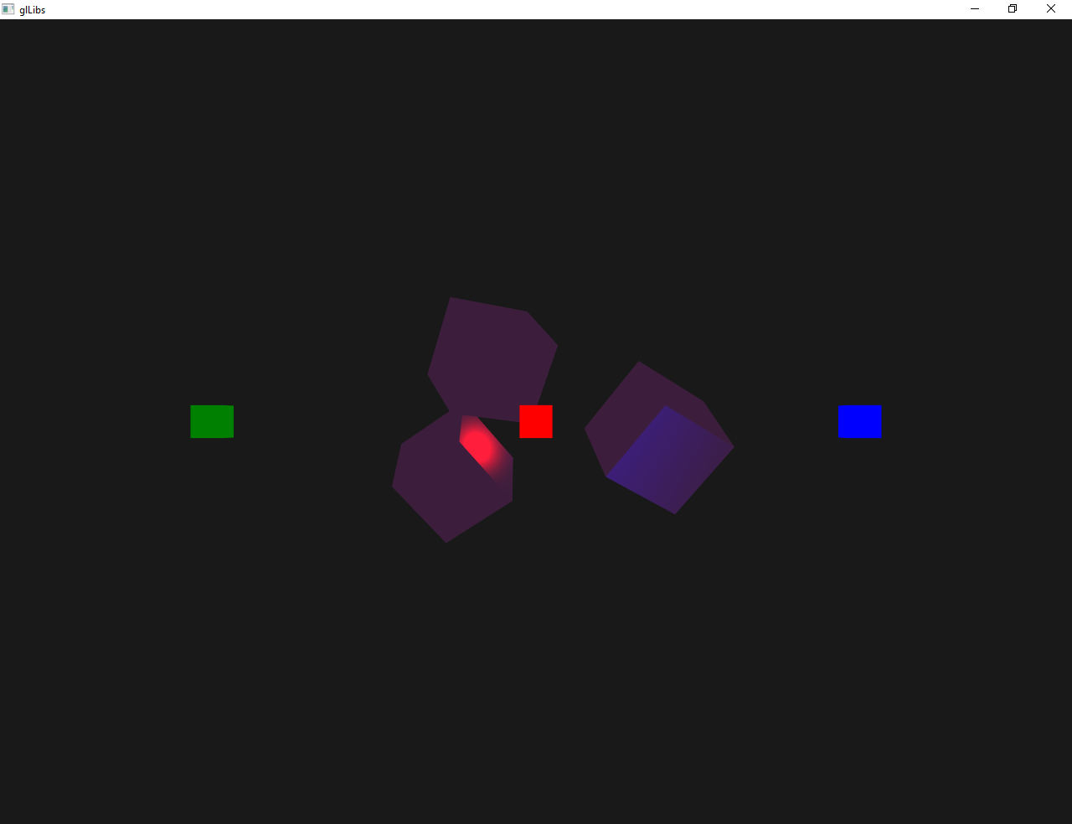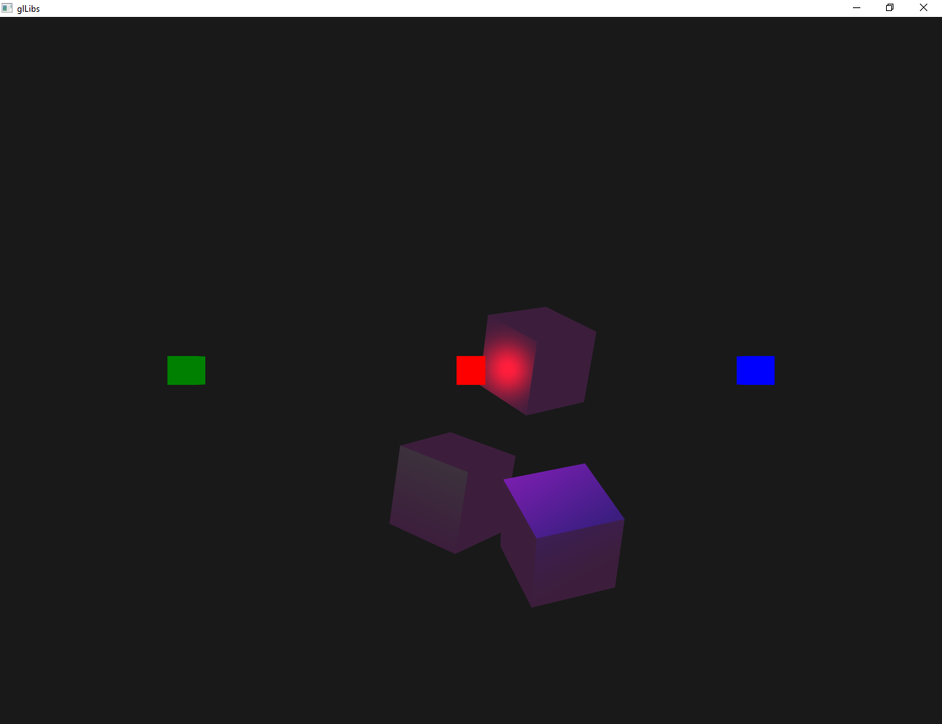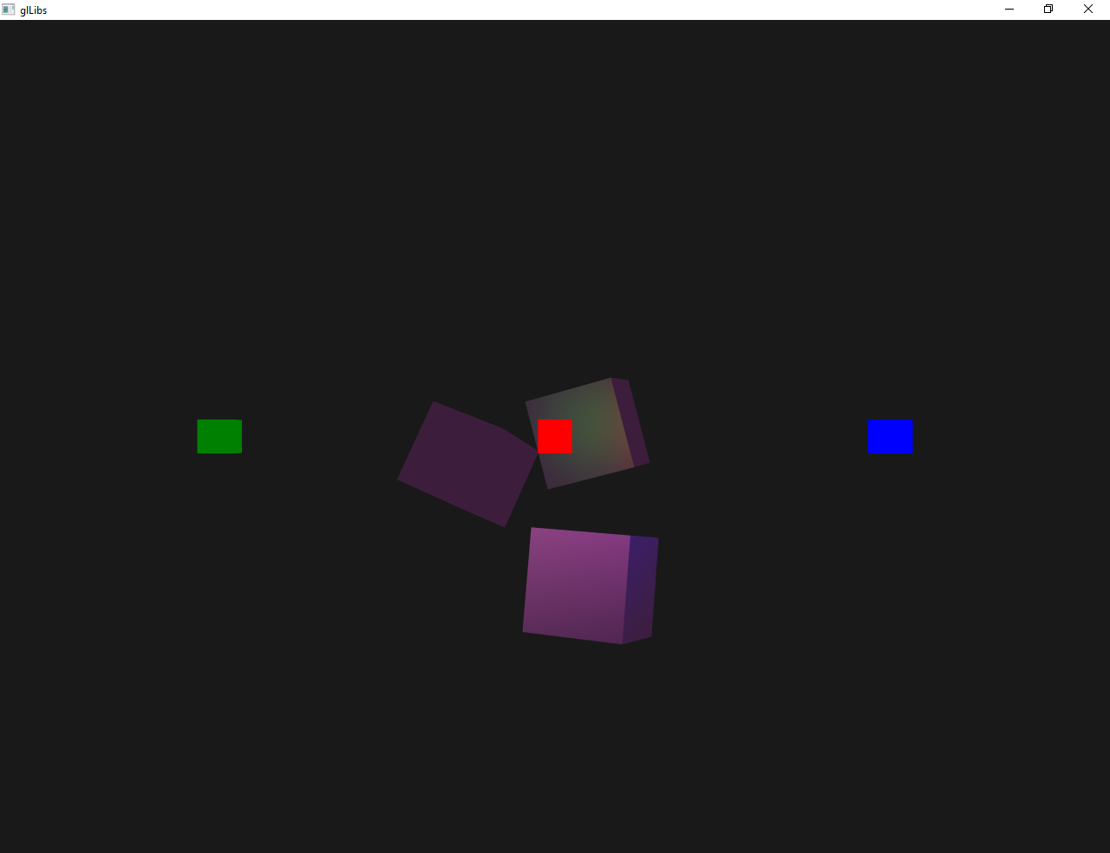
Рис. 1. Результат работы программы

